主标题：rugged tablet pc
副标题：Y100 rugged tablet pc
Key features:
MT6789 (2 Arm) ® Cortex-A76 core, operating frequency of 2.2GHz, 6 Arm ® Cortex-A55 core, operating at a frequency of 2.0GHz
Memory :8G+128G Optional:8G+256G
10.1-inch resolution 800 * 1280 optional: 1200X1920
2G,3G,4G wireless communication,NFC
Barcode, QR code scanning

rugged tablet pc -1
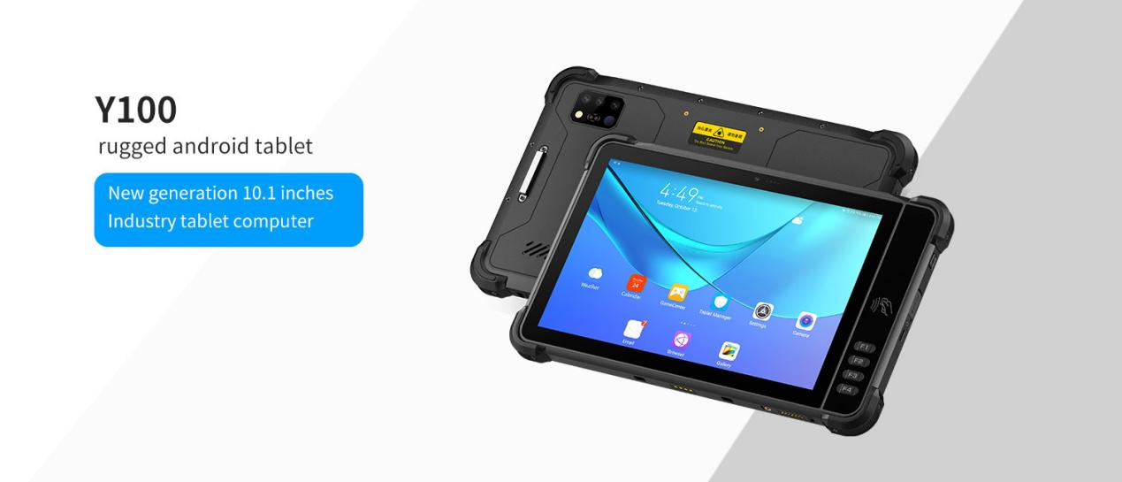
Y100 is 10.1-inch rugged tablet pc by LQYCIT. 10.1-inch high-definition large screen, equipped with a high-performance 8-core 2.2GHz processor, Android 13 operating system, 8G+128G memory, 4G communication, WIFI，GPS，BT。 Built in 10000mAh high-capacity battery with IP67 protection level.
Optional functions: barcode, QR code scanning, NFC, other functional modules.
Strong industry adaptability, widely used in material management, vehicle intelligence, warehousing and logistics, smart factories, medical, municipal and other application fields. Help users quickly achieve information management and improve enterprise operational efficiency.
Equipped with an 8-core 2.2GHz processor, Android 16 operating system, and standard 8G+128G memory, it runs faster and more stable.
IP67 dustproof and waterproof; The body is made of high-strength industrial grade materials, which are sturdy and durable. Can meet the 1-meter high-altitude drop test.
10.1-inch high-definition display screen, supporting multi touch, glove touch, water operation, and passive pen signature.
Built in 10000mAh large capacity battery, with a long battery life, can meet the needs of long-term outdoor work.

rugged tablet pc -2
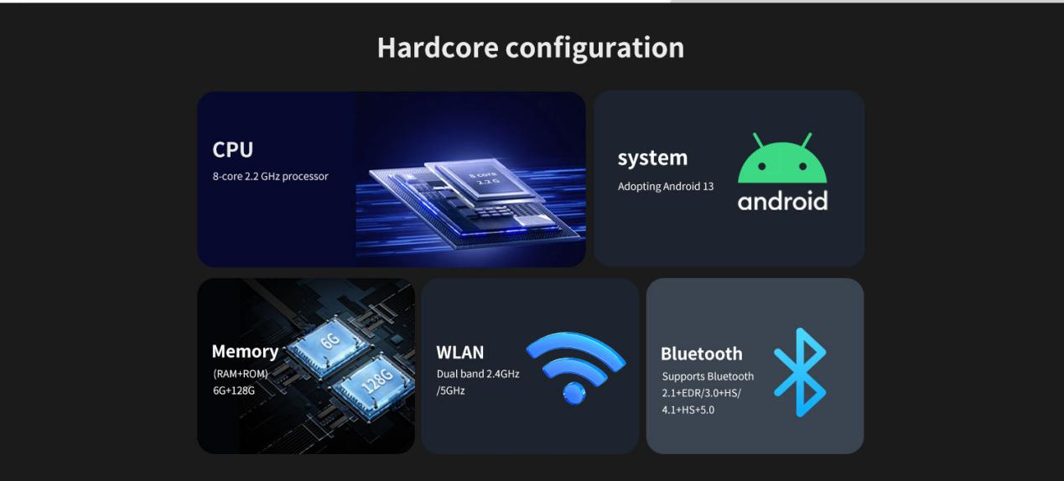
rugged tablet pc -3
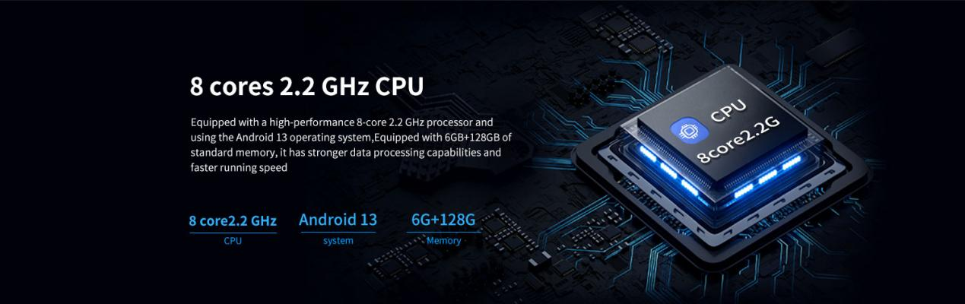
Hardcore configuration
rugged tablet pc carry High performance 8-core 2.2GHz processor, Android 16 operating system, 8GB+128GB memory, faster and more stable running speed
rugged tablet pc -4
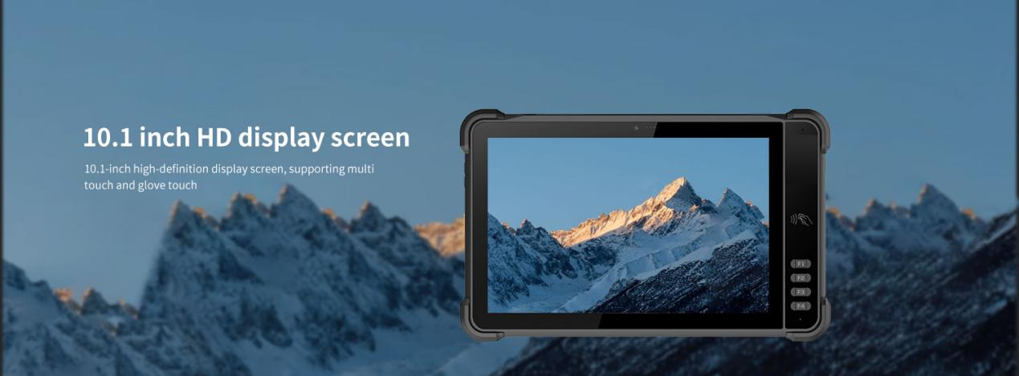
10.1-inch high-definition large screen
High resolution 1920x1200, with clear and delicate images. The high brightness screen (550nits) can maintain clear visibility even under strong light, allowing outdoor workers to not worry about light interference and ensuring bright and clear visual effects in various environments.
Paired with sensitive 10 point touch technology, the operation is smooth and natural. Whether it's clicking, sliding, or zooming, it can respond quickly, bringing users an efficient and convenient operating experience.
rugged tablet pc -5
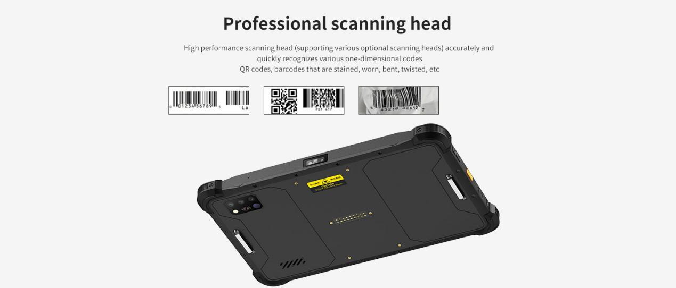
Barcode, QR code scanning (Optional)
High performance scanning engine, accurately and quickly identifying various barcodes, QR codes, as well as colored, worn, bent, twisted barcodes, etc
Scan engine：E60\CM60\N1
1D Symbologies：UPC/EAN, Code128, Code39, Code93, Code11, Interleaved 2 of 5, Discrete 2 of 5, Chinese 2 of 5, Codabar, MSI, RSS, etc.
2D Symbologies：PDF417, MicroPDF417, Composite, RSS, TLC-39, Datamatrix, QR code, Micro QR code, Aztec, MaxiCode; Postal Codes: US PostNet, US Planet, UK Postal, Australian Postal, Japan Postal, Dutch, Postal (KIX), etc.
rugged tablet pc -6
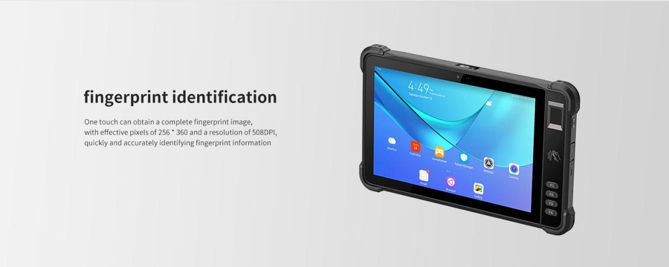
fingerprint identification (Optional)
One touch can obtain a complete fingerprint image,with effective pixels of 256 *360 and a resolution of 508DPlquickly and accurately identifyingfingerprint information

rugged tablet pc -7
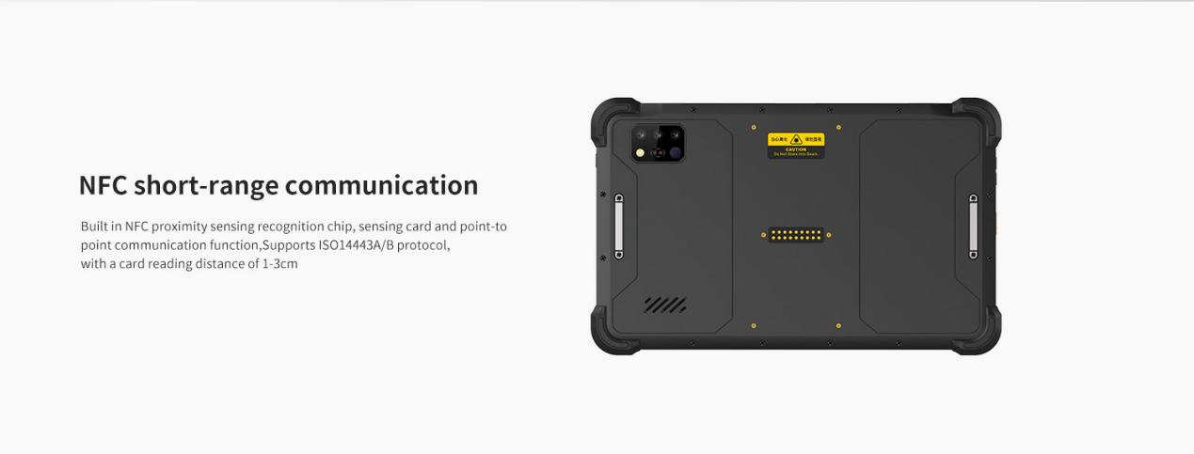
NFC short-range communication
Built in NFC proximity sensing recognition chip, sensing card and point-to-point communication function, supports ISO14443A/B protocol, card reading distance 1-3cm
rugged tablet pc -8
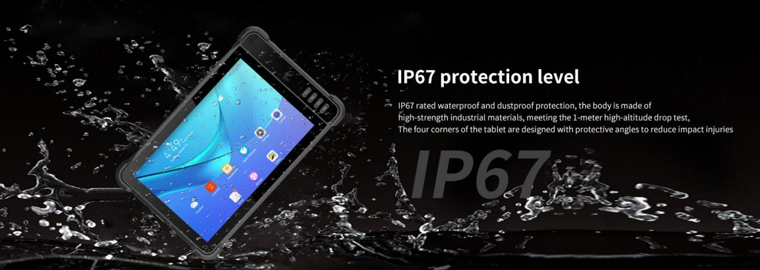
Protection level
IP67 dustproof and waterproof; The body is made of high-strength industrial materials, which are sturdy and durable, and can meet the requirements of a 1-meter high-altitude drop test. The four corners of the tablet are designed with protective angles, effectively reducing impact injuries.
rugged tablet pc -9


Provide ODM and OEM customized services
• We work closely with our partners and can provide various one-stop customized solutions.
• Appearance customization: supports customization of product nameplates, product packaging, and promotional materials.
• Hardware customization: Supports customization of functional modules and optional hardware functions.
• Software customization: supports customization of boot interface, boot program, kernel clipping, and API interface.
• Technical support: Provide SDK development kits and application software development technical services.

Y100 is 10.1-inch multifunctional rugged tablet pc by LQYCIT. 10.1-inch high-definition large screen, equipped with a high-performance 8-core 2.2GHz processor, Android 16 operating system, standard 8G+128G memory, 4G communication, WIFI，GPS，BT。 Built in 10000mAh high-capacity battery with IP67 protection level.
Optional functions: barcode, QR code scanning, NFC, RFID reader, biometric fingerprint recognition, night vision camera, infrared thermal imaging camera and other functional modules.
Strong industry adaptability, widely used in animal husbandry management, bank material management, military equipment material management, clothing inventory, vehicle management, high-speed toll collection, warehouse management, intelligent factories, medical, municipal and other application fields. Help users quickly achieve information management and improve enterprise operational efficiency.

HARDWARE CUSTOMIZATION
1: Nameplate Logo Customization
2:Packaging Custom Design
﻿
SOFTWARE CUSTOMIZATION
1:Boot Screen Customization
2:System Function Hiding
3:Built-in Customer App
4:Customer App Auto-launch
5:Platform Software Integration
6:Fixed MAC Address
7:Download Prohibition
﻿8:USB Disablement
﻿9:APP Installation and Uninstallation Control
10:Pre-installed APK
﻿11:Camera Control
12:Provide System Signing Files

frequently asked questions
Q: Are you the original manufacturer?

A: Yes, we are the original manufacturer. We have our own brand LQYCIT. All of our products have complete patented ID/MD designs, hardware and software, molds, and assembly are all completed by our own team.

Q: Can you pre install our software?

A: Yes, we can pre install your software.

Q: What is the minimum order quantity?

A: We accept standard product orders starting from one unit. If necessary, we can even customize your logo. For OEM, our sales team will review the detailed requirements and confirm the minimum order quantity.

Q: Can we get free samples?

A: Sorry, we usually do not provide free samples. If the customer confirms the specifications and pricing, they can first order samples for testing and evaluation.

Q: How to place an order and make payment?

A: We accept wire transfers (bank transfers), Alibaba online payments, and Western Union remittances.

Q: What is the warranty period for your products?

A: We offer a 12-month warranty after shipment.

Q: How long is the delivery time?

A: The production delivery cycle is about 3-10 days, depending on the requirements. The delivery time through DHL/UPS/FedEx/TNT is approximately 3-5 working days. For some remote areas, the transportation time may be longer.

Q: How to fix equipment problems?

A: We will provide online technical support to solve problems. For hardware issues, we can ship parts or components for customers to install (if they have technicians), or we can ship them back to us for repairs.

